### MINI PROJECT

**(2020-21)**

**Build Quiz Website (quiz overpowered)**

### MID-TERM REPORT



**Institute of Engineering & Technology**

**Submitted by-**

**Kunal singh (181500341)**

**Harshit sachan (181500257)**

**Shivam Kumar (181500668)**

**Utkarsh Agarwal (181500769)**

**Rahul Kumar (181500534)**

***Supervised By: - Mrs.RuchGupta***

Technical Trainer

### Department of Computer Engineering & Applications

**Department of Computer Engineering and Applications**

**GLA University, Mathura**

**17 km. Stone NH#2, Mathura-Delhi Road, P.O. – Chaumuhan,**

**Mathura – 281406**

**Declaration**

I hereby declare that the work which is being presented in the Mini Project **“Quiz Overpowerd”,**

partial fulfillment of the requirements for Mini project Lab is an authentic record of my own

work carried under the supervision of **Mr. Anand Gupta, Technical Trainer.**

**Kunal Singh**

**Shivam Kuamr Rai**

**Rahul Kumar**

**Harshit Sachan**

**Utkarsh Agarwal**



**Department of Computer Engineering and Applications**

**GLA University, Mathura**

**17 km. Stone NH#2, Mathura-Delhi Road, P.O. – Chaumuha,**

**Mathura – 281406**

**Certificate**



**ACKNOWLEDGEMENT**

It gives us a great sense of pleasure to present the report of the B. Tech Mini Project undertaken during B. Tech. Third Year. This project in itself is an acknowledgement to the inspiration, drive and technical assistance contributed to it by many individuals. This project would never have seen the light of the day without the help and guidance that we have received.

Our heartiest thanks to Dr. (Prof). Anand Singh Jalal, Head of Dept., Department of CEA for providing us with an encouraging platform to develop this project, which thus helped us in shaping our abilities towards a constructive goal.

We owe special debt of gratitude to Mr. Anand Gupta, Technical Trainer, for his constant support and guidance throughout the course of our work. His sincerity, thoroughness and perseverance have been a constant source of inspiration for us. He has showered us with all his extensively experienced ideas and insightful comments at virtually all stages of the project & has also taught us about the latest industry-oriented technologies.

We also do not like to miss the opportunity to acknowledge the contribution of all faculty members of the department for their kind guidance and cooperation during the development of our project. Last but not the least, we acknowledge our friends for their contribution in the completion of the project.

**Kunal Singh**

**Shivam Kuamr Rai**

**Rahul Kumar**

**Harshit Sachan**

**Utkarsh Agarwal**



**Content**

## INTRODUCTION 6

**Exesting system and need of the system Scope of the work**

**Operating Environment**

**. Hardware Specification**

**. Software Specification**

#### Detail Description of Technology Used

## Component diagram

**PROPOSED SYSTEM**

**6**

# 6-7

**7-8**

**8-13**

**. Proposed System**

**. Objectives of Proposed system**

**. User Requirement**

Test Proceduresand Implementation 19

. Test Procedure

. Login

Usermanual 19-21

**. Purpose**

**. Drawbacks and Limitations**

**. Proposed Enhancements**

## Conclusion SCREEN SHOTS

**Code**

**Bibliography**

 **21**

**22-30**

**31-55**

**51**

**INTRODUCTION**

On-line examinations contents providers to focus on creating effective assessment questions and focusing on exam’s feedback delivery to students. In the paper we present techniques that are pertinent to the elements of assessment process: answers submission, computerized grading, and feedback after submission.

As the modern organizations are automated and computers are working as per the instructions, it becomes essential for the coordination of human beings, commodity and computers in a modern organization.

The administrators, instructor , Students who are attending for online examination can communicate with the system through this projects, thus facilitating effective implementation and monitoring of various activities of Online Examinations like conducting Exams as per scheduled basis and delivering result to that particular use or student. And the details of students who attempted

Online Examination are maintained at administrator.

## Existing System & need of the System :

Existing system is a manual one in which users are maintaining books to store the information like Student Details, Instructor Details, Schedule Details and feedbacks about students who attempted exam as per schedule.. It is very difficult to maintain historical data.

## Scope of Work :

Technological advancements in this era of digitization along with being a boon

to the world have been advantageous to the educational sector too. The introduction of online exam software replaced the conventional system of assessment. The various examination conducting agencies are now able to evaluate the test takers freely and cost-effectively through computer-based tests. Today’s article discusses the scope and objectives of an online examination system.

let us understand the concept of online examination software. Exam software allows users to take online tests and automatically generate results based on the answers marked by the users.

Lets now discuss the reasons for the introduction of online examination in the modes of conducting an assessment.

#### Conduct exams effortless:

Computer-based tests as a method of conducting an assessment enable users to manage an exam easily. The functionalities of an exam software such as user-friendly dashboard, multiple languages, support for multiple

question types and formats, detailed reporting, automatic instant results help in smooth conduction

#### Reduce exam anxiety Amongst test takers:

The flexibility associated with computer-based tests reduces exam anxiety among test takers as they can take the exam at any time of the day that coincides with their preferred sleep/ wake cycle.

#### Promote social interaction between the test taker and experts:

An online environment promotes exam preparation with experts or peers as they can review the course content together. Online assessment possible through exam software lays the real foundation of academic teaching as it facilitates discussion with teachers or other students.

#### Prevents cheating:

Cheating amongst the test-takers in the examination hall is one of the major drawbacks of pen paper-based assessment. Online examination managed avoids the possibilities of secretly using unfair means to get the right answers. The presence of various functionalities in exam software prevents cheating irrespective of the test taker’s location.

#### Safe and secure data:

Various tools offered by exam software have enabled the assessment conducting agencies to manage the crucial data related to examination questions and

test-takers safely.

#### Reduce administrative burden:

Organizing and running exams online not only reduces an organization’s administrative burden but also saves cost and time. Online examination with its objective to make evaluation massive but simple, cost-effective and faster has replaced the pen paper-based assessment. The examination managing agencies have started preferring computer- based test to instill their lost faith in the method of conducting an evaluation. Thus online

examination software offered by Pesofts is one of the most advanced software for conducting tests.

## Operating Environment

#### HARDWARE SPECIFICATION

Client side RAM 512 MB Hard Disk 40 GB

Processor Intel Core Duo or higher

Server Side RAM 2 GB or higher Hard Disk 80 GB or higher Processor Intel CoreDuo or higher

#### Software Specification

Client side Operating System Windows 7& above Web Browser IE 6 & above Mozilla Firefox 6 &above Google Chrome 6 & above

Server Side

Operating system Windows 7 & above Database Server SQL Server 2008& above

#### Detail Description of Technology Used

Following is the brief description about various technologies used while designing this system

#### HTML(Hyper Text Markup Language):

**HTML** stands for Hyper Text Markup Language. It is used to design web pages using markup language. HTML is the combination of Hypertext and Markup language. Hypertext defines the link between the web pages. Markup language is used to define the text document within tag which defines the structure of web pages. HTML is a markup language used by the browser to manipulate text, images and other content, in order to display it in the required format.

HTML provides a means to create structured documents by denoting structural semantics for text such as headings, paragraphs, lists, links, quotes and other items. HTML elements are delineated by *tags*, written using angle brackets. Tags such as <img/> and <input/>directly introduce content into the page. Other tags such as <p> surround and provide information about document text and may include other tags as sub-elements.

##### CSS(****C****ascading ****S****tyle ****S****heets):

CSS, is a simply designed language intended to simplify the process of making web pages present CSS

allows you to apply styles to web pages.CSS enables you to do this independenttheHTML that makes up

each web page. CSS handles the look and feel part of a web page. Using CSS, you can control the color

of thetext, the style of fonts, the spacing between paragraphs, how columns are sized and

laid out, what background images or colors are used, layout designs,variations in display for different

devices and screen sizes as well as a variety of other effects.

## Advantages of CSS:

 CSS saves time-You can write CSS once and then reuse same sheet in multiple HTML pages.You can define a style for each HTML element and apply it to as many Web pagesas you want

**Easy maintenance-**To make a global change, simply change the style, and all elements

in all the web pages will be updated automatically.

**Multiple Device Compatibility** -Style sheets allow content to be optimized for more

than one type of device. By using the same

HTML document, different versions of a website can be presented for handheld devices such as PDAs and

cell phones or for printing.

#### JavaScript:-

JavaScript is an object-oriented scripting language used to enable programmatic access to object s within both the client application and other applications. It is primarily used in the form of client-side JavaScript, implemented as an integrated component of the web browser, allowing the development of enhanced user interfaces and dynamic websites. JavaScript is a dialect of the ECMA Script standard and is characterized as a dynamic, weakly typed, prototype-based language with first-class functions. JavaScript was influenced by many languages and was designed to look like Java, but to be easier for non-programmers to work with. JavaScript was originally developed by Brendan Eich of Netscape under the name Mocha, whichwas later renamed to Live Script, and finally to JavaScript.

#### Apache:

The name 'Apache' was chosen from respect for the Native American Indian tribe of Apache, well-known for their superior skills in warfare strategy and their inexhaustible endurance. It also makes a cute pun on "a patchy web server”

a server made from a series of patches but this was not its origin. The group of developers who released this new software soon started to call themselves the "Apache Group".

#### Bootstrap:

Bootstrap is a free and open-source tool collection for creating responsive websites and

web applications. It is the most popular HTML, CSS, and JavaScript framework for

developing responsive, mobile-first web sites. It solves many problems which we had once,

one of which is the cross-browser compatibility issue.the websites are perfect for all the

browsers (IE, Firefox and Chrome) and for all sizes of screens (Desktop, Tablets, Phablets,

and Phones).

* Bootstrap is a free front-end framework for faster and easier web development
* Bootstrap includes HTML and CSS based design templates for typography, forms, buttons, tables, navigation, modals, image.carousels and many other, as well as optional JavaScript plugins.



jQuery:

jQuery is an open source JavaScript library that simplifies the interactions between

an HTML/CSS document, or more precisely the Document Object Model (DOM),

and JavaScript.Elaborating the terms, jQuery simplifies HTML document traversing

and manipulation, browser event handling, DOM animations, Ajax interactions, and

cross-browser JavaScript development.

jQuery's syntax is designed to make it easier to navigate a document, select

[DOM](https://en.wikipedia.org/wiki/Document_Object_Model) elements, create [animations](https://en.wikipedia.org/wiki/Animation), handle [events](https://en.wikipedia.org/wiki/Event_(computing)), and develop [Ajax](https://en.wikipedia.org/wiki/Ajax_(programming)) applications.

jQuery also provides capabilities for developers to create [plug-ins](https://en.wikipedia.org/wiki/Plug-in_(computing)) on top of the

JavaScript library. This enables developers to create [abstractions](https://en.wikipedia.org/wiki/Abstraction_(computer_science)) for low-level

interaction and animation, advanced effects and high-level, themeable widgets.

The modular approach to the jQuery library allows the creation of powerful [dynamic](https://en.wikipedia.org/wiki/Dynamic_web_page" \o "Dynamic web page)

[web pages](https://en.wikipedia.org/wiki/Dynamic_web_page" \o "Dynamic web page) and Web applications.

# MYSQL:

MySQL is an open source relational database management system (RDBMS).

Its name is a combination of "My", the name of co-founder Michael Widenius's

daughter, and "SQL", the abbreviation for Structured Query Language.

MySQL is an open-source relational database management system (RDBMS).

It is the most popular.MySQL is released under an open-source license. So you

have nothing to pay to use it.MySQL is a very powerful program in its own right.

It handles a large subset of the functionality of the most expensive and powerful

database packages.MySQL works on many operating systems and with many

languages including PHP, PERL, C, C++, JAVA, etc.MySQL is customizable.

The open-source GPL license allows programmers to modify the MySQL software

to fit their own specific environments.MySQL is very friendly to PHP, the

most appreciated language for web development.MySQL works very quickly and

works well even with large data sets.

## Node.js:

Node.js is a server-side platform built on Google Chrome's JavaScript Engine

(V8 Engine). Node.js was developed by Ryan Dahl in 2009 and its latest version

is v0.10.36.Node.js is an open source, cross-platform runtime environment for

developing server-side and networking applications. Node.js applications are

written in JavaScript, and can be run within the Node.js runtime on OS X,

Microsoft Windows, and LinuxNode.js also provides a rich library of various

JavaScript modules which simplifies the development of web applications using

Node.js to a great extent.

## 

## Features of Node.js:

* Asynchronous and Event Driven − All APIs of Node.js library are asynchronous, that is, non-blocking. It essentially means a Node.js based server never waits for an API to return data. The server moves to the next API after calling it and a notification mechanism of Events of Node.js helps the server to get a response from the previous API call.
* Very Fast − Being built on Google Chrome's V8 JavaScript Engine, Node.js library is very fast in code execution.
* Single Threaded but Highly Scalable − Node.js uses a single threaded model with event looping. Event mechanism helps the server to respond in a non-blocking way and makes the server highly scalable as opposed to traditional servers which create limited threads to handle requests. Node.js uses a single threaded program and the same program can provide service to a much larger number of requests than traditional servers like Apache HTTP Server.
* No Buffering − Node.js applications never buffer any data. These applications simply output the data in chunks.

### ExpressJS:

ExpressJS is a web application framework that provides you with a simple

API to build websites, web apps and back ends. Express provides a minimal

interface to build our applications.It provides us the tools that are required to

build our app. It is flexible as there are numerous modules available on npm,

which can be directly plugged into Express.Express.js is a web framework for

Node.js. It is a fast, robust and asynchronous in nature.It can be used to design

single-page, multi-page and hybrid web applications.

* It allows to setup middlewares to respond to HTTP Requests.
* It defines a routing table which is used to perform different actions based on HTTP method and URL.
* It allows to dynamically render HTML Pages based on passing arguments to templates.

**VISUAL STUDIO:**

Microsoft Visual Studio is an integrated development environment (IDE) from

Microsoft. It is used to develop computer programs, as well as websites, web apps,

web services and mobile apps. Visual Studio uses Microsoft software

development platforms such as Windows API, Windows Forms, Windows

Presentation Foundation, Windows Store and Microsoft Silverlight. It can

produce both native code and managed code.

Visual Studio includes a code editor supporting IntelliSense (the code

completion component) as well as code refactoring.

The integrated debugger works both as a source-level debugger and a

machine-level debugger. Other built-in tools include a code profiler, forms

designer for building GUI applications, web designer, class designer, and database

schema designer. It accepts plug-ins that enhance the functionality at almost every

level—including adding support for source control systems (like Subversion and Git)

and adding new toolsets like editors and visual designers for domain-specific languages

or toolsets for other aspects of the software development lifecycle (like the

Team Foundation Server client: Team Explorer).

Visual Studio supports 36 different programming languages and allows the code editor

and debugger to support (to varying degrees) nearly any programming language,

provided a language-specific service exists. Built-in languages include C,[6]

C++, C++/CLI, Visual Basic .NET, C#, F#,JavaScript, TypeScript, XML, XSLT,

HTML, and CSS.

# APIs:

API is an abbreviation for Application Programming Interface which is a collection

of communication protocols and subroutines used by various programs to

communicate between them. A programmer can make use of various API tools to

make its program easier and simpler.A developer extensively uses API’s in his software

to implement various features by using an API call without writing the complex codes

for the same. We can create an API for an operating system, database systems,

hardware system, for a JavaScript file or similar object oriented files. API is similar to

a GUI(Graphical User Interface) with one major difference. Unlike GUI’s, an API

helps the software developers to access the web tools while a GUI helps to make

a program easier to understand by the users.

**Types of APIs:**

**WEB APIs:**

A Web API also called as Web Services is an extensively used API over the web and can be easily accessed using the HTTP protocols. A Web API is an open source interface and can be used by a large number of clients through their phones, tablets. or PC’s.

**LOCAL APIs:**

In this types of API, the programmers get the local middleware services.

TAPI (Telephony Application Programming Interface), .NET are

common examples of Local API’s.

**PROGRAM APIs:**

It makes a remote program appears to be local by making use of RPC’s (Remote Procedural Calls). SOAP is a well-known example of this type of API.

**Advantages of APIs –**

* **Efficiency:**API produces efficient, quicker and more reliable results than the outputs produced by human beings in an organization.
* **Flexible delivery of services:**API provides fast and flexible delivery of services according to developers requirements.
* **Integration:**The best feature of API is that it allows movement of data between various sites and thus enhances integrated user experience.
* **Automation:**As API makes use of robotic computers rather than humans, it produces better and automated results.
* **New functionality**: While using API the developers find new tools and functionality for API exchanges.

**Disadvantages of APIs –**

* **Cost:**Developing and implementing API is costly at times and requires high maintenance and support from developers.
* **Security issues:**Using API adds another layer of surface which is then prone to attacks, and hence the security risk problem is common in API’s.

# 

# COMPONENT DIAGRAM

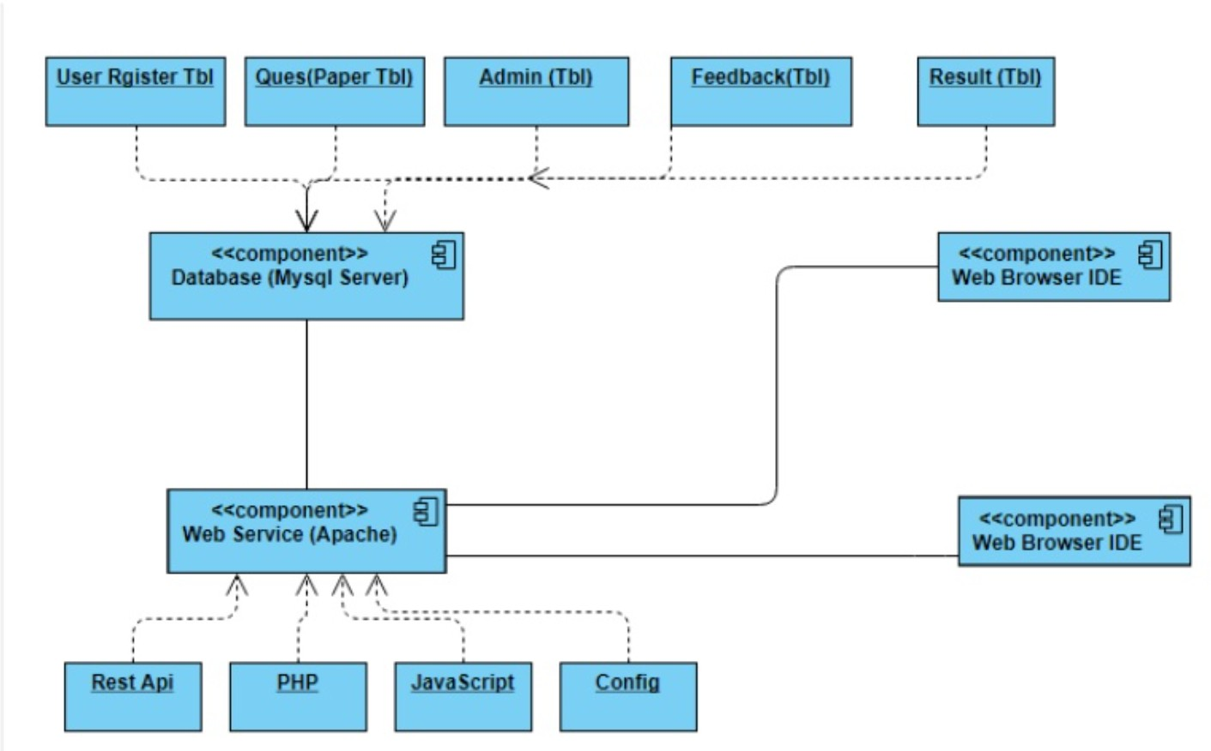



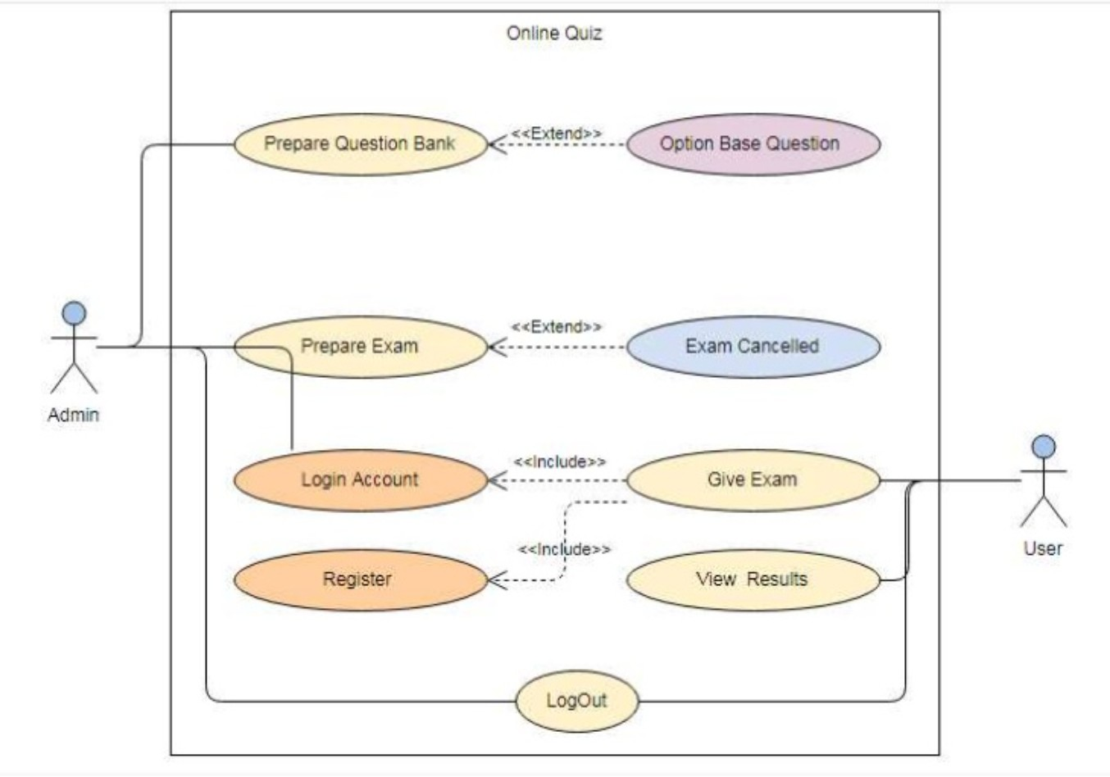**ONLINE QUIZ**

**HIERARCHY DIAGRAM**

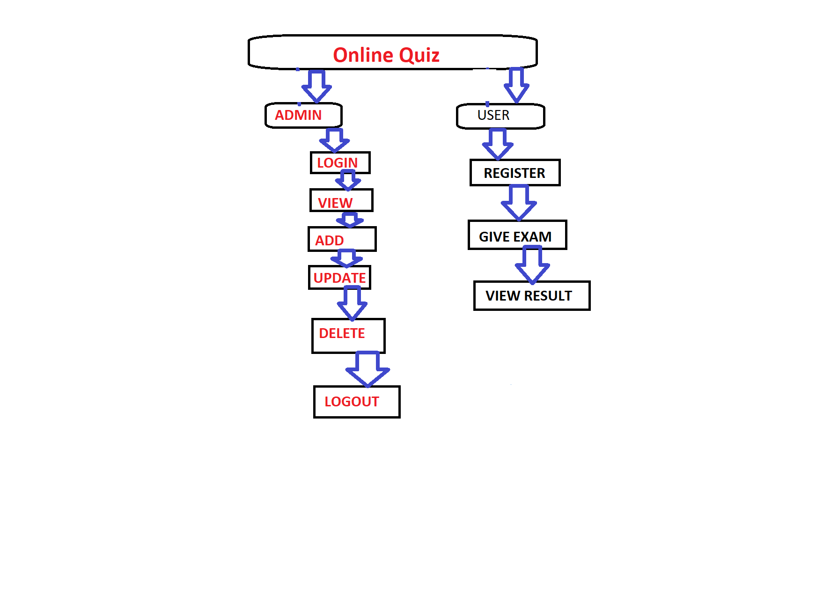

### MICROSOFT SQL SERVER

Microsoft SQL Server is a relational database management system developed by Microsoft. As a database, it is a software product whose primary function is to store and retrieve data as requested by other software applications, be it those on the same computer or those running on another computer across a network (including the Internet). There are at least a dozen different editions of Microsoft SQL Server aimed at different audiences and for workloads ranging from small single-machine applications to large Internet-facing applications with many concurrent users.

Its primary query languages are T-SQL and ANSI-SQL.

**PROPOSED SYSTEM**

#### Proposed System

**This application is used to conduct online examination. The students can sit at individual terminals and login to write the exam in the given duration. . The questions have to be given to the students. This application will perform correction, display the result immediately and also store it in database. This application provides the administrator with a facility to add new exams. This application provides the Instructor add questions to the exam, modify questions in the exam in a particular exam. This application takes care of authentication of the administrator, Instructor as well as the student.**

#### Objectives of Proposed system

The objective of the Online Examination Tool is to provide better information for the users of this system for better results for their maintainence in student examination schedule details and grading details.

#### User Requirement

1. **User must be computer literate.**
2. **Each user has their authentication when placing the order i.e user requested to register first before login.**
3. **Customer has their mobile number & address required for their authentication.**
4. **User provide with smart garbage dustbin that must be kept in safe and proper way as the cost of the dustbin is to much so user requested to keep the dustbin like her own dustbin not thought that it’s a company productand damage to dustbin the customer will be liable.**

## Test Procedures and Implementation

#### Test Procedure

The project need to be fully tested as it needs to be integrated to an internal existing system. Also the data that it processes and its accuracy as equally important. Since system works on the network it was thoroughly tested internally and can only then he implemented inclemently to the other modules.

**Login**

Whenever user will open the site & he want to perform any operations, Contract. User must have click on login. User is login with his user id and password then he/she will go to next page that is Home page. For valid user name and password user must register with the system.

## User Manual

This manual will be order to get overall idea about the system this is to be used.

This manual will explain the need scope of a user manual as well as outline the suggested organisation and content of user manual

### Purpose:

A user manual is prepared just before the implementation phase in the system development life cycle. The objective of the user manual is too clearly described and documents the operating of the system for the user department, in specific, non-ambiguous and non-technical terms.

The ultimate test for any system is whether it can be used efficiently and effectively.

A system can’t implement itself. It needs to people to start, use and maintain it, but they must learn how. Providing documentation that teaches how is the part of responsibility of every individual, as member of the system development team.

The need for user manual arises for the following reasons

1. **The user manual represents the entry point into the system from the end user angle.**
2. **The manual identifies the task which must be carried out by the user, in using the system, the objectives of these takes and main deliverables which signify successful completion of each task.**
3. **In many cases the manual is the sole means of learning how to the work or how to correct errors.**
4. **A comprehensive user manual describes in details all system inputs processor,**

outputs and control and provides background reading to supplement training and testing.

The steps using this portal are as follows:

1. **The very first step for this portal is user-login.**
2. **The user is checked authentication.**
3. **Once the user is authenticated user, main screen appear.**
4. **He/she is able to access the desired page and makes manipulation with data.**
5. **The user can add in the database.**

### User manual for Developers:

This manual will be order to get overall idea about the system for the developers.

This manual will explain how the system has been developed? , which are the technologies are used for development? Which coding architecture is followed by the developers?

### Coding Architecture:

* 1. **tier architecture is used for the development of cooped.**

Application Layer Business Layer Database Access Layer

Technology Used:

For the Application Layer

-PHP: used to create .php pages and allow for the dynamic web content.

-HTML: used to create the static web content.

-CSS, JavaScript & AJAX: used for the client side validations, to make the user interface attractive.

For the Business Access Layer

-PHP: used to handle the .php pages as well as various namespaces and classes. For the Database Access Layer

-MS-SQL 2008: used for the data storage and data manipulation.

### Drawbacks and Limitations

* + 1. **User must be computer literate**
    2. **If internet is not provided then can’t book the dustbin**

### Proposed Enhancements

1. **This application avoids the manual work and the problems concern with it. It is an easy way to obtain the information regarding the different scheduled examinations information that are Currently issued.**
2. **We will make it more user friendly.**
3. **The enhancement that we can add the searching option. We can directly search to the particular student details from this site.**

## Conclusion

#### The package was designed in such a way that future modifications can be done easily. The following conclusions can be deduced from the development of the project.

**Automation of the entire system improves the efficiency**

**It provides a friendly graphical user interface which proves to be better when compared to the existing system.**

**It gives appropriate access to the authorized users depending on their permissions.**

**It effectively overcomes the delay in communications. Updating of information becomes so easier.**

**System security, data security and reliability are the striking features.**

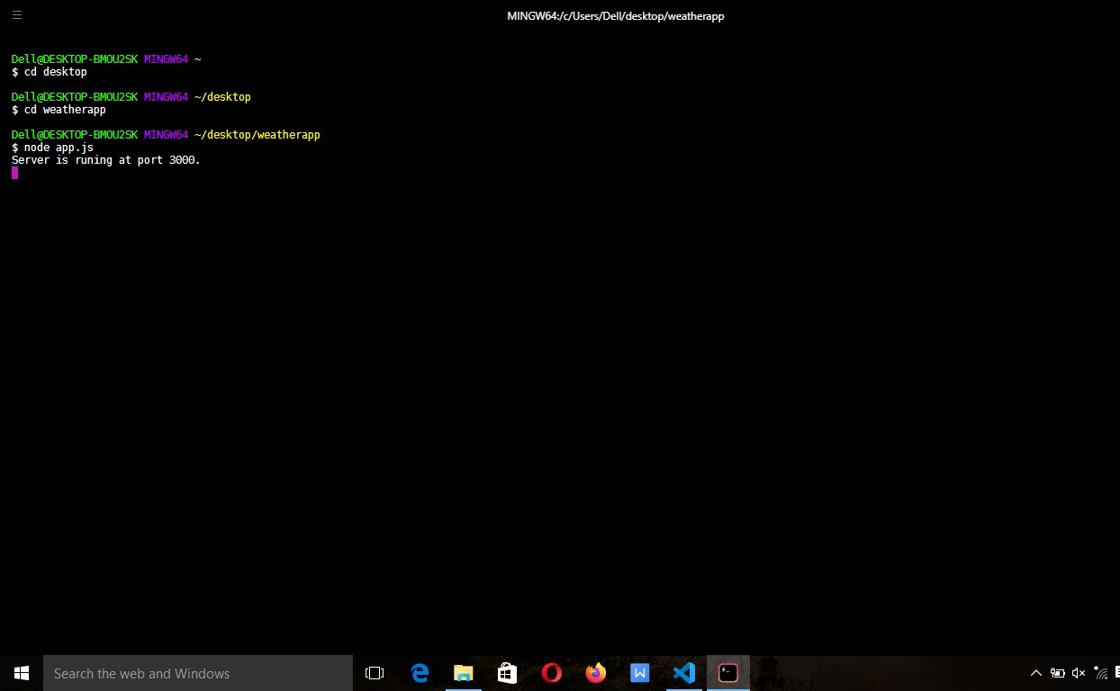**SCREEN SHOT**

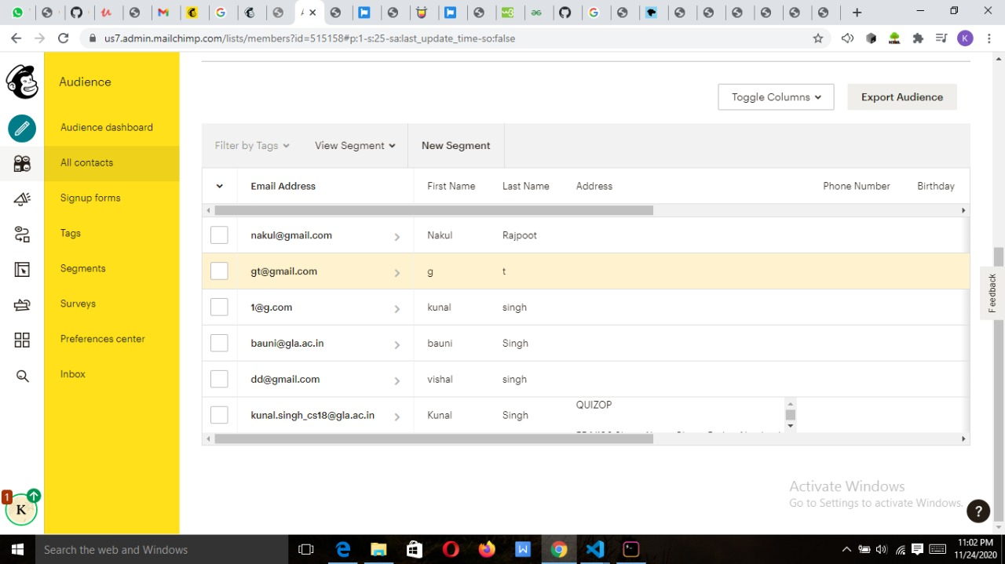

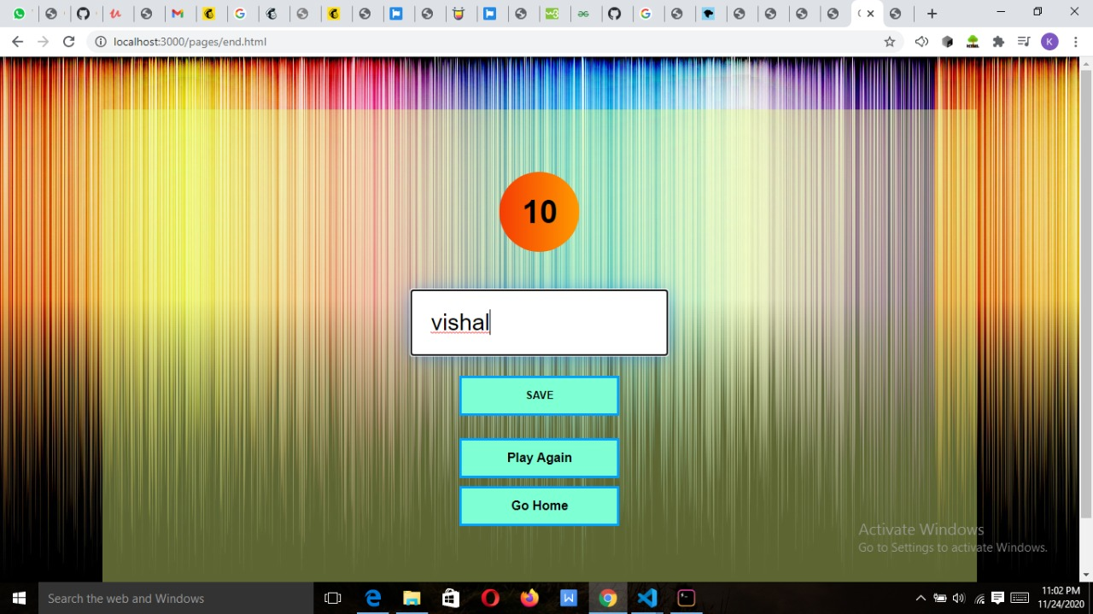

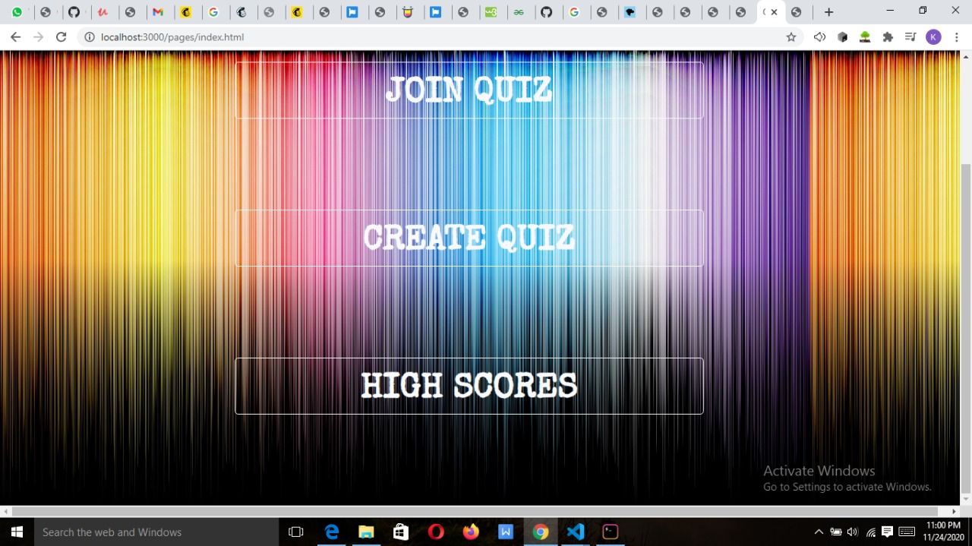

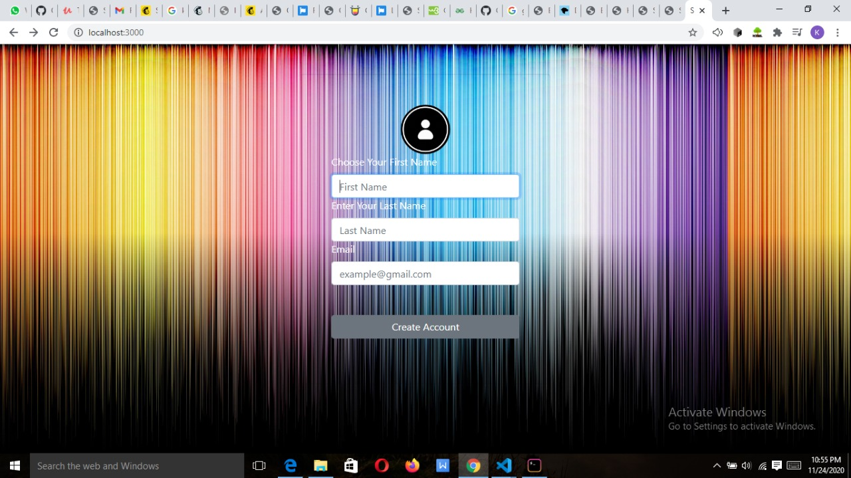

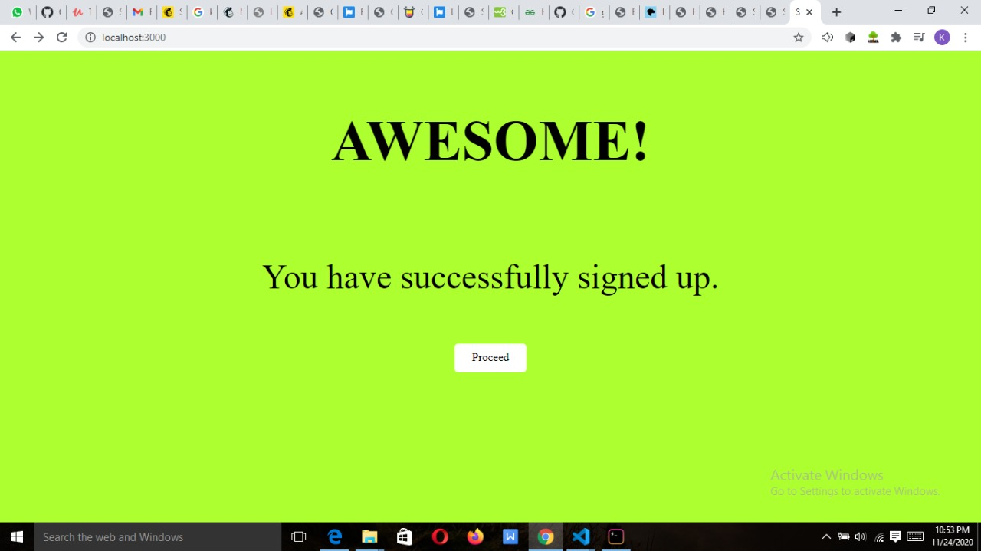

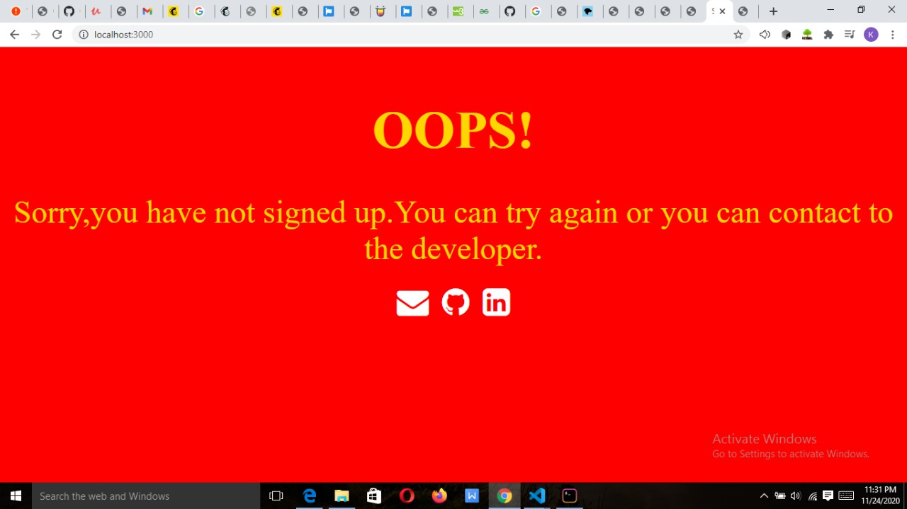

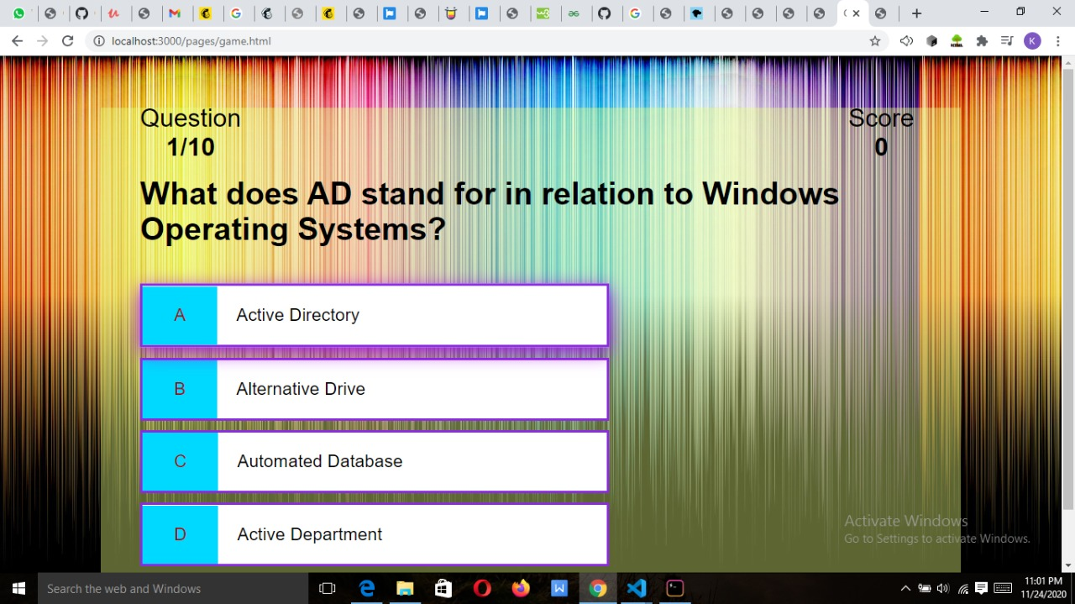

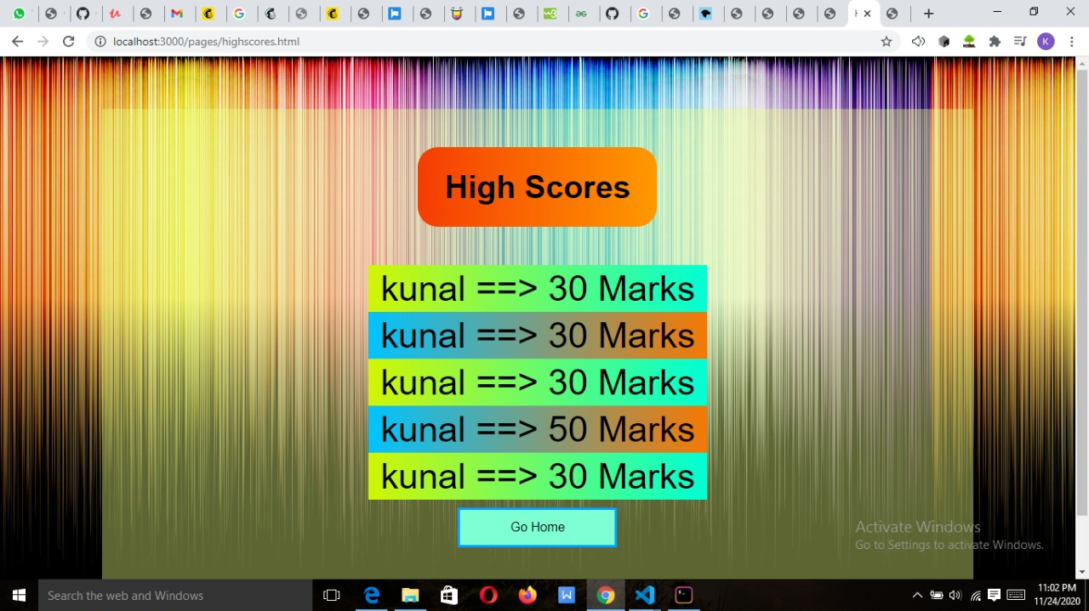

**Implementation and user interface**

**CODE**

##### Signup-page.html:

<!DOCTYPE html>

<html lang="en">

<head>

<meta charset="UTF-8">

<meta name="viewport" content="width=device-width, initial-scale=1.0">

<link rel="stylesheet" href="https://stackpath.bootstrapcdn.com/bootstrap/4.5.2/css/bootstrap.min.css" integrity="sha384-JcKb8q3iqJ61gNV9KGb8thSsNjpSL0n8PARn9HuZOnIxN0hoP+VmmDGMN5t9UJ0Z" crossorigin="anonymous">

<link rel="stylesheet" href="../css/signupstyle.css">

<script src="https://code.jquery.com/jquery-3.5.1.slim.min.js" integrity="sha384-DfXdz2htPH0lsSSs5nCTpuj/zy4C+OGpamoFVy38MVBnE+IbbVYUew+OrCXaRkfj" crossorigin="anonymous"></script>

<script src="https://cdn.jsdelivr.net/npm/popper.js@1.16.1/dist/umd/popper.min.js" integrity="sha384-9/reFTGAW83EW2RDu2S0VKaIzap3H66lZH81PoYlFhbGU+6BZp6G7niu735Sk7lN" crossorigin="anonymous"></script>

<script src="https://stackpath.bootstrapcdn.com/bootstrap/4.5.2/js/bootstrap.min.js" integrity="sha384-B4gt1jrGC7Jh4AgTPSdUtOBvfO8shuf57BaghqFfPlYxofvL8/KUEfYiJOMMV+rV" crossorigin="anonymous"></script>

<title>SIGN UP</title>

</head>

<body>

<div class="card" style="width: 25rem;">

<img src="../images/user-login-human-man-body-512.png">

<form action="/" method="POST">

<label for="exampleFormControlInput1">Choose Your First Name</label>

<input type="text" class="form-control" name="fname" placeholder="First Name" required autofocus>

<label for="exampleFormControlInput1">Enter Your Last Name</label>

<input type="text" class="form-control" name="lname" placeholder="Last Name" required>

<label for="exampleFormControlInput1">Email</label>

<input type="email" class="form-control" name="email" placeholder="example@gmail.com" required><br><br>

<button type="submit" id="button" class="btn btn-block btn-secondary ">Create Account</button>

<br>

</form>

</div>

</body>

</html>

**Index.html:**

<!DOCTYPE html>

<html lang="en">

<head>

<meta charset="UTF-8">

<meta name="viewport" content="width=device-width, initial-scale=1.0">

<!-- CSS Stylesheets -->

<link rel="stylesheet" href="https://stackpath.bootstrapcdn.com/bootstrap/4.5.2/css/bootstrap.min.css" integrity="sha384-JcKb8q3iqJ61gNV9KGb8thSsNjpSL0n8PARn9HuZOnIxN0hoP+VmmDGMN5t9UJ0Z" crossorigin="anonymous">

<link href="https://fonts.googleapis.com/css2?family=Special+Elite&display=swap" rel="stylesheet">

<!-- Bootstrap Scripts -->

<script src="https://code.jquery.com/jquery-3.5.1.slim.min.js" integrity="sha384-DfXdz2htPH0lsSSs5nCTpuj/zy4C+OGpamoFVy38MVBnE+IbbVYUew+OrCXaRkfj" crossorigin="anonymous"></script>

<script src="https://cdn.jsdelivr.net/npm/popper.js@1.16.1/dist/umd/popper.min.js" integrity="sha384-9/reFTGAW83EW2RDu2S0VKaIzap3H66lZH81PoYlFhbGU+6BZp6G7niu735Sk7lN" crossorigin="anonymous"></script>

<script src="https://stackpath.bootstrapcdn.com/bootstrap/4.5.2/js/bootstrap.min.js" integrity="sha384-B4gt1jrGC7Jh4AgTPSdUtOBvfO8shuf57BaghqFfPlYxofvL8/KUEfYiJOMMV+rV" crossorigin="anonymous"></script>

<title>QuizOP</title>

<style>

body{

background-image: url(../images/pexels-pixabay-326311.jpg) ;

background-size: contain;

font-family: 'Special Elite', cursive;

background-attachment: fixed;

}

.navbar-brand{

font-size: 2.5rem;

font-weight: bold;

color: #411f1f;

}

.nav-link{

font-size: 1.5rem;

font-weight: bold;

color: #411f1f;

}

.download-button{

margin: 8rem 50%;

height: 5rem;

font-weight: bolder;

font-size: 3rem;

}

</style>

</head>

<body>

<nav class="navbar navbar-expand-lg navbar-dark">

<a class="navbar-brand" href="">Quiz OverPowered</a>

<button class="navbar-toggler" type="button" data-toggle="collapse" data-target="#navbarTogglerDemo01" aria-controls="navbarTogglerDemo01" aria-expanded="false" aria-label="Toggle navigation">

<span class="navbar-toggler-icon"></span>

</button>

<div class="collapse navbar-collapse" id="navbarTogglerDemo01">

<ul class="navbar-nav ml-auto">

<li clas="nav-item">

<a class="nav-link" href="../public/pages/login-page.html"></a>

</li>

<li clas="nav-item">

<a class="nav-link" href="../public/pages/signup-page.html"></a>

</li>

</ul>

</nav>

<div class="row">

<div class="col-lg-6">

<a href="../pages/game.html" class="btn btn-lg btn-block btn-outline-light download-button">JOIN QUIZ</a>

<a href="https://opentdb.com/api_config.php" class="btn btn-lg btn-block btn-outline-light download-button">CREATE QUIZ</a>

<a href="../pages/highscores.html" class="btn btn-lg btn-block btn-outline-light download-button">HIGH SCORES</a>

</div>

</div>

</body>

</html>

**Start.html:**

<!DOCTYPE html>

<html lang="en">

<head>

<meta charset="UTF-8">

<meta name="viewport" content="width=device-width, initial-scale=1.0">

<link rel="stylesheet" href="../css/startcss.css">

<script defer src="../start.js"></script>

<title>Quiz app</title>

</head>

<body >

<div class="container">

<div id="question-container" class="hide">

<div id="question">Question</div>

<div id="answer-buttons" class="btn-grid">

<button class="btn">Answer1</button>

<button class="btn">Answer2</button>

<button class="btn">Answer3</button>

<button class="btn">Answer4</button>

</div>

</div>

<div class="controls">

<button id="start-btn" class="start-btn btn">Start</button>

<button id="next-btn" class="next-btn btn hide">Next</button>

</div>

</div>

</body>

</html>

**Highscores.html:**

<!DOCTYPE html>

<html lang="en">

<head>

<meta charset="UTF-8">

<meta name="viewport" content="width=device-width, initial-scale=1.0">

<title>HighScores</title>

<link rel="stylesheet" href="../css/highscores.css">

</head>

<body>

<div class="container">

<div id="end">

<h1 id="highscores">High Scores</h1>

<ul id="highScoresList"></ul>

<a class="btn" href="../pages/index.html">Go Home</a>

</div>

</div>

<script src="../JS/highscores.js"></script>

</body>

</html>

**Game.html:**

<!DOCTYPE html>

<html lang="en">

<head>

<meta charset="UTF-8">

<meta name="viewport" content="width=device-width, initial-scale=1.0">

<title>QuizOP Game</title>

<link rel="stylesheet" href="../css/games.css">

</head>

<body>

<div class="container">

<div id="gamer">

<div id="hud">

<div id="hud-item">

<p class="hud-prefix">Question</p>

<h1 class="hud-main-text" id="questionCounter"></h1>

</div>

<div id="hud-item">

<p class="hud-prefix">Score</p>

<h1 class="hud-main-text" id="score"> 0</h1>

</div>

</div>

<br>

<h2 id="question">Here is the current hardcoded question dgjnsdndt jkhy ythry ,kyt,tukfud??</h2>

<div class="choice-container">

<p class="choice-prefix">A</p>

<p class="choice-text" data-number="1">Choice 1</p>

</div>

<div class="choice-container">

<p class="choice-prefix">B</p>

<p class="choice-text" data-number="2">Choice 2</p>

</div>

<div class="choice-container">

<p class="choice-prefix">C</p>

<p class="choice-text" data-number="3">Choice 3</p>

</div>

<div class="choice-container">

<p class="choice-prefix">D</p>

<p class="choice-text" data-number="4">Choice 4</p>

</div>

<br>

</div>

</div>

<script src="../JS/game.js"></script>

</body>

</html>

**End.html:**

<!DOCTYPE html>

<html lang="en">

<head>

<meta charset="UTF-8">

<meta name="viewport" content="width=device-width, initial-scale=1.0">

<title>Quiz Result</title>

<link rel="stylesheet" href="../css/end.css">

</head>

<body>

<div class="container">

<div id="end">

<h1 id="finalScore">0</h1>

<form>

<input type="text" name="username" id="username" placeholder="username">

<button

type="submit"

class="btn"

id="saveScoreBtn"

onclick="saveHighScore(event)"

disabled

>

<b>SAVE</b>

</button>

</form>

<br>

<a href="../pages/game.html" class="btn"><b>Play Again</b></a>

<a href="../pages/index.html" class="btn"><b>Go Home</b></a>

</div>

</div>

<script src="../JS/end.js"></script>

</body>

</html>

**fail.html:**

<!DOCTYPE html>

<html lang="en">

<head>

<meta charset="UTF-8">

<meta name="viewport" content="width=device-width, initial-scale=1.0">

<link rel="stylesheet" href="https://cdnjs.cloudflare.com/ajax/libs/font-awesome/4.7.0/css/font-awesome.min.css">

<title>SignUP failed</title>

<style>

*{

padding: 0;

margin: 0;

box-sizing: border-box;

}

body{

background-color: red;

}

h1{

text-align: center;

font-size: 5rem;

color: gold;

margin-top: 80px;

margin-bottom: 50px;

}

p{

text-align: center;

font-size: 3rem;

color: gold;

margin-bottom: 20px;

}

div{

display: flex;

justify-content: center;

align-items: center;

}

a{

padding: 10px;

color: white;

}

</style>

</head>

<body>

<h1>OOPS!</h1>

<p>Sorry,you have not signed up.You can try again or you can contact to the developer.</p>

<div>

<a href=""><i class="fa fa-envelope fa-3x center"></i></a>

<a href="https://github.com/"><i class="fa fa-github fa-3x center"></i></a>

<a href=""><i class="fa fa-linkedin-square fa-3x center"></i></a>

</div>

</body>

</html>

**Success.html:**

<!DOCTYPE html>

<html lang="en">

<head>

<meta charset="UTF-8">

<meta name="viewport" content="width=device-width, initial-scale=1.0">

<title>Signed up successfully</title>

</head>

<style>

body{

padding: 0;

margin: 0;

box-sizing: border-box;

background-color: greenyellow;

}

h1{

font-size: 5rem;

color: black;

margin-top: 80px;

margin-bottom: 50px;

text-align: center;

}

p{

font-size: 3rem;

color: black;

text-align: center;

}

div{

width: 100px;

height: 30px;

text-align: center;

background-color: white;

padding-top: 10px;

margin: 0 auto;

border-radius: 5px;

}

div:hover{

background-color: black;

}

a{

color:black ;

text-decoration: none;

}

a:hover{

color: white;

}

</style>

<body>

<h1>AWESOME!</h1><br>

<p>You have successfully signed up.</p><br>

<div><a href="../pages/index.html">Proceed</a></div>

</body>

</html>

**Style.css:**

body{

background-image: url(../images/pexels-pixabay-326311.jpg) ;

background-size: contain;

font-family: 'Special Elite', cursive;

background-attachment: fixed;

}

.navbar-brand{

font-size: 2.5rem;

font-weight: bold;

color: #411f1f;

}

.nav-link{

font-size: 1.5rem;

font-weight: bold;

color: #411f1f;

}

.download-button{

margin: 8rem 50%;

height: 5rem;

font-weight: bolder;

font-size: 3rem;

}

**Games.css:**

body{

background-image: url(../images/pexels-pixabay-326311.jpg) ;

background-size: contain;

font-family: 'Special Elite', cursive;

background-attachment: fixed;

}

*{

box-sizing: border-box;

margin:0px;

padding: 0px;

color: black;

font-family: Arial, Helvetica, sans-serif;

}

h2{

font-size: 2.5rem;

margin-bottom: 3rem;

}

#gamer{

display: inline;

}

.container{

width: 80vw;

height: 90vh;

min-height:600px;

margin: 10vh auto;

background-color: rgb(232, 255, 127,0.40);

display: flex;

align-items: center;

padding: 50px 50px;

justify-content: center;

}

.choice-container:hover{

cursor: pointer;

box-shadow: 0 0.4rem 1.4rem 0 rgb(163, 17, 230);

transform: translateY(-0.1rem);

transition: 150ms;

}

.choice-container{

margin-top: 12px;

display: flex;

margin-bottom: 0.2rem;

width:60%;

font-size: 1.4rem;

border: 0.2rem solid blueviolet;

background-color: white;

}

.choice-prefix{

padding:1.5rem 2.5rem;

background-color: rgb(0, 217, 255);

color: rgb(153, 16, 16);

}

.choice-prefix:hover{

background:linear-gradient(to right, rgb(245, 60, 4) ,rgb(255, 153, 0));

}

.choice-text{

padding:1.5rem;

width:100%;

}

/* .choice-text:hover{

background:linear-gradient(to right, rgb(173, 245, 4) ,yellow);

transition-duration: 200ms;

} */

#question{

max-width: 100%;

}

.correct{

background:linear-gradient(to right, rgb(173, 245, 4) ,yellow);

}

.incorrect{

background:linear-gradient(to right, rgb(247, 4, 4) ,rgb(255, 94, 0));

}

#hud{

width:72vw;

display: flex;

justify-content: space-between;

}

.hud-prefix{

text-align: center;

font-size: 2rem;

}

.hud-main-text{

text-align: center;

}

**Highscores.css:**

body{

background-image: url(../images/pexels-pixabay-326311.jpg) ;

background-size: contain;

font-family: 'Special Elite', cursive;

background-attachment: fixed;

}

*{

box-sizing: border-box;

margin:0px;

padding: 0px;

color: black;

font-family: Arial, Helvetica, sans-serif;

}

h1{

display: flex;

align-items: center;

justify-content: center;

height: 100px;

width: 300px;

border-radius: 25px;

background:linear-gradient(to right, rgb(245, 60, 4) ,rgb(255, 153, 0));

font-size: 2.5rem;

margin-bottom: 3rem;

}

.btn{

height: 50px;

width: 200px;

line-height: 40px;

display: flex;

align-items: center;

justify-content: center;

padding: 5px 40px;

text-decoration: none;

background-color: aquamarine;

border: solid rgb(0, 162, 255);

margin-top: 10px;

}

#end{

width:100%;

display: flex;

align-items: center;

flex-direction: column;

}

.container{

width: 80vw;

height: 90vh;

min-height:600px;

margin: 10vh auto;

background-color: rgb(232, 255, 127,0.40);

display: flex;

align-items: center;

padding: 50px 50px;

justify-content: center;

}

#highScoresList{

display: flex;

justify-content: center;

flex-direction: column;

background:linear-gradient(to right, rgb(209, 245, 4) ,rgb(0, 255, 213));

list-style: none;

}

#highScoresList li{

padding: 4px 15px;

}

#highScoresList li:nth-child(even){

background:linear-gradient(to right,rgb(0, 195, 255),rgb(245, 120, 4) );

width:100%;

}

/* #highScoresList li::before {

content: '*';

color: red;

display: inline-block;

width: 1em;

margin-left: -1em;

} */

.high-score{

font-size: 2.8rem;

}

.high-score:hover{

}

**Server.js:**

const express=require("express");

const bodyParser=require("body-parser")

const request=require("request");

const https=require("https")

const app=express()

app.use(express.static('public'))

// app.set('view engine', 'ejs');

app.use(bodyParser.urlencoded({extended:true}));

app.get("/",function(req,res){

res.sendFile(__dirname+"/signup-page.html");

});

app.post("/",function(req,res){

const firstname=req.body.fname;

const lastname=req.body.lname;

const email=req.body.email;

const data={

members:[

{

email_address:email,

status:"subscribed",

merge_fields:{

FNAME:firstname,

LNAME:lastname

}

}

]

};

const jsonData=JSON.stringify(data);

const url="https://us7.api.mailchimp.com/3.0/lists/efc09b987e";

const options={

method:"POST",

auth:"kunal7:afb3a091239a9673381ca4fc9c44b395-us7"

}

const request=https.request(url,options,function(response){

if(response.statusCode===200){

res.sendFile(__dirname+"/success.html");

} else{

res.sendFile(__dirname+"/fail.html");

}

response.on("data",function(data){

console.log(JSON.parse(data));

})

})

request.write(jsonData);

request.end();

});

app.listen(process.env.PORT||3000,function(){

console.log("Server is running at port 3000");

})

## End.js:

const username = document.getElementById('username');

const saveScoreBtn = document.getElementById('saveScoreBtn');

const finalScore = document.getElementById('finalScore');

const mostRecentScore = localStorage.getItem('mostRecentScore');

const highScores = JSON.parse(localStorage.getItem("highScores")) || [];

const MAX_HIGH_SCORES = 5;

finalScore.innerText = mostRecentScore;

username.addEventListener("keyup",() =>{

saveScoreBtn.disabled = !username.value;

});

saveHighScore = e =>{

console.log("clicked the save button");

e.preventDefault();

const score = {

score: mostRecentScore,

name: username.value

};

highScores.push(score);

highScores.sort((a,b) =>{

return b.score > a.score

});

highScores.splice(MAX_HIGH_SCORES);

localStorage.setItem("highScores" , JSON.stringify(highScores));

window.location.assign("../pages/index.html");

};

## Games.js:

const quest=document.getElementById("question");

const choices=Array.from(document.getElementsByClassName("choice-text"));

const questionCounterText=document.getElementById("questionCounter");

const scoreText=document.getElementById("score");

let currentQuestion={};

let acceptingAnswers = false;

let score=0;

let questionCounter=0;

let avaliableQuestions=[];

let questions =[];

// fetch("https://opentdb.com/api.php?amount=20&category=18&difficulty=easy&type=multiple") //20 easy cs questions

fetch("https://opentdb.com/api.php?amount=10&category=18&difficulty=medium&type=multiple") //10 medium cs questions

.then(res =>{

return res.json();

})

.then(loadedQuestions => {

console.log(loadedQuestions.results);

questions = loadedQuestions.results.map(loadedQuestion =>{

const formattedQuestion = {

question: loadedQuestion.question

};

const answerChoices = [...loadedQuestion.incorrect_answers];

formattedQuestion.answer = Math.floor(Math.random()*3) + 1;

answerChoices.splice(

formattedQuestion.answer - 1,0,loadedQuestion.correct_answer

);

answerChoices.forEach((choice,index) => {

formattedQuestion["choice"+(index + 1)] = choice;

});

return formattedQuestion;

});

startGame();

})

.catch(err =>{

console.error(err);

});

// fetch("../JSON/questions.json")

// .then(res=>{

// return res;

// });

//constants

const Marks_per_Correct = 10;

const Total_Questions = 10; //or use questions.length;

startGame = () =>{

questionCounter=0;

score=0;

avaliableQuestions =[...questions];

getNewQuestion();

};

getNewQuestion = () =>{

if(avaliableQuestions.length ==0 || questionCounter >= Total_Questions){

localStorage.setItem('mostRecentScore',score);

console.log("Game Over");

return window.location.assign("../pages/end.html");

}

questionCounter++;

questionCounterText.innerText = questionCounter + '/' + Total_Questions;

//Creating a random number

const QuesIndex = Math.floor(Math.random() * avaliableQuestions.length);

currentQuestion = avaliableQuestions[QuesIndex];

//Inserting New question into yhe array

quest.innerText = currentQuestion.question;

//Filling up options in the choices-container

choices.forEach( choice => {

const number = choice.dataset['number'];

choice.innerText = currentQuestion['choice'+number];

});

//removing the used question from the arrray

avaliableQuestions.splice(QuesIndex,1); //Second argument 1 for removing one element from aur array

acceptingAnswers=true;

};

choices.forEach( choice => {

choice.addEventListener('click',e=>{

if(acceptingAnswers==false) return;

acceptingAnswers=true;

const selectedChoice = e.target;

const selectedAnswer = selectedChoice.dataset["number"];

var classToApply = 'incorrect';

if(selectedAnswer == currentQuestion.answer){

classToApply = 'correct';

}

if(classToApply ==='correct'){

incrementScore(Marks_per_Correct);

}

console.log(classToApply);

//Adding this variable 'classToApply' as class to the parent of selected choice for applying CSS.

selectedChoice.parentElement.classList.add(classToApply);

setTimeout(()=>{

selectedChoice.parentElement.classList.remove(classToApply);

getNewQuestion();

},300);

});

});

incrementScore = num =>{

score += num;

scoreText.innerText = score;

}

## Questions.json:

[

{

"question": "This is question no 1... do you know ?? (2)",

"choice1" : "this is choice1",

"choice2" : "this is choice2",

"choice3" : "this is choice3",

"choice4" : "this is choice4",

"answer" : 2

},

{

"question": "This is question no twoo---... do you know ?? (3)",

"choice1" : "this is choice1 option",

"choice2" : "this is choice2 option",

"choice3" : "this is choice3 option",

"choice4" : "this is choice4 option",

"answer" :3

},

{

"question": "This is question no threee... do you know ??(1)",

"choice1" : "this is choice1",

"choice2" : "this is choice2",

"choice3" : "this is choice3",

"choice4" : "this is choice4",

"answer": 1

},

{

"question" : "This is question no 4... do you know the answer??(4)",

"choice1" : "this is choice1",

"choice2" : "this is choice2",

"choice3" : "this is choice3",

"choice4" : "this is choice4",

"answer" : 4

}

]

## Package.json:

{

"name": "quizop",

"version": "1.0.0",

"description": "quizop server",

"main": "server.js",

"scripts": {

"test": "echo \"Error: no test specified\"&& exit 1",

"start": "node server.js"

},

"repository": {

"type": "git",

"url": "git+https://github.com/KunalSingh777/QuizOP.git"

},

"author": "Kunal Singh",

"license": "ISC",

"bugs": {

"url": "<https://github.com/KunalSingh777/QuizOP/issues>"

},

"homepage": "<https://github.com/KunalSingh777/QuizOP#readme>",

"dependencies": {

"body-parser": "^1.19.0",

"ejs": "^3.1.5",

"express": "^4.17.1",

"request": "^2.88.2"

}

}

**Bibliography**

1. **Object Oriented Analysis and Design with Applications by Grady Booch.**
2. **Object Oriented Software Engineering – Ivar Jacobson Pearson Education** [**3 www.wikipedia.com**](http://www.wikipedia.com/)
3. [**www.c-sharpcorner.com**](http://www.c-sharpcorner.com/)
4. [**www.slideshare.com**](http://www.slideshare.com/)
5. [**www.google.com**](http://www.google.com/)
6. [**www.w3Cschool.com**](http://www.w3Cschool.com/)